

**Elk Valley Minor Hockey Association**

**General Meeting Agenda**

**March 5, 2023**

**CALL TO ORDER**

The regular meeting of the Elk Valley Minor Hockey Association was called to order at 6:00 pm on March 4, 2023 in Sparwood.

**ATTENDEES: Stephanie Freiheit, Tanya Wagner, Stephanie Doraty, Nikole Sharpe, Jillian Doey, Crystal Tennant, Jenna Kaus, Sky Johnston, Jeff Pryhitko, and Jason Lui**

**REGRETS SENT: Jeff Pryhitko, Crystal Tennant**

**Guests Present**:

Motion to adopt the Meeting Minutes.

1st the motion – Melissa

2nd the motion- Jillian

All approved

**BOARD REPORTS**

**PRESIDENT’S REPORT- TIFFANY RYBACHUK**

**Submitted Report:**

**VICE PRESIDENT’S REPORT- Crystal Tennant**

**Submitted Report: Nothing to Update**

**TREASURER’S REPORT- Tanya Wagner**

**Report Submitted: November 2022**

**Financial Report:**

Bank Balances as of February 6th

General Account - 68947.92

Gaming Account - 1105.58

Bonds - 5510.88 each

Raiders - 2002.87

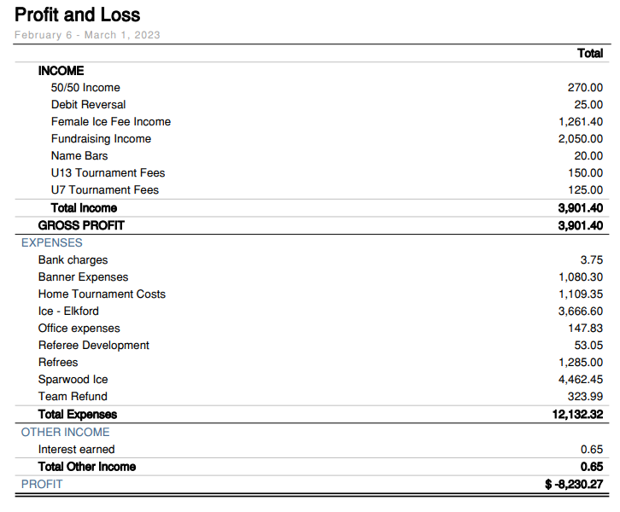

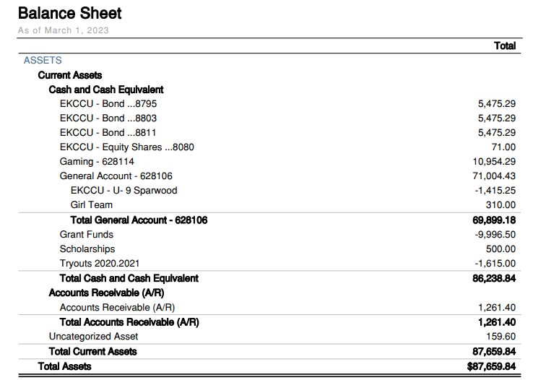

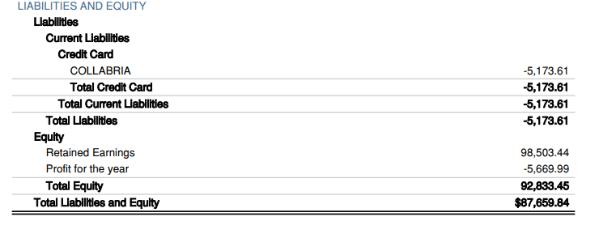

|  |
| --- |
|  |

**EK REP- Jeff Pryhitko**

**Report Submitted**: **None Submitted**

**CROSS ICE COORDINATOR- Jenna Kaus**

**Report Submitted:**

I would be willing to apply for the first-shift program but I have a few questions for the Board.

I have ordered the reusable tournament signs.

I encourage everyone to have a look at Draft 16 of the Policy Handbook. It includes the motioned and agreed-upon updates for dual rostering. As per our discussion at the last meeting, Tanya and I have created/discussed the new home tournament policy. Have a look (pages 18 & 19).

I Have reviewed the EKMHA policies, and nothing I could find contradicts them.

From what I know, our only policy that is different from a specific BC Hockey/Hockey Canada Policy is our dressing room policy. We have decided that females can wear sports bras in co-ed dressing rooms. The Hockey Canada Policy states t-shirt.

Nothing else in the handbook has changed since our last meeting.

**REFEREE IN CHIEF- Vacant**

**Report Submitted:**

**COACH COORDINATOR- JEFF CYTKO**

**Report Submitted:**

**EQUIPMENT MANAGER- Sky Johnston**

**Report Submitted: None Submitted**

**REGISTRAR- Stephanie Doratty**

**Report Submitted: Nothing to Update**

**PUBLIC RELATIONS/WILD WEAR- Jillian Doey**

**Report Submitted: Nothing to Update**

**ICE COORDINATOR- Melissa Archambault**

**Report Submitted: None Submitted**

**RISK MANAGER- Jenn Attorp**

**Report Submitted: None Submitted**

**SPECIAL EVENTS COORDINATOR- Justine Bowen**

**Report Submitted: None Submitted**

**FUNDRAISING COORDINATOR- Stephanie Frieheit**

**Report Submitted: None Submitted**

**FEMALE COORDINATOR- Jason Lui**

**Report Submitted: None Submitted**

**PLAYER DEVELOPMENT- Vacant**

**Report Submitted:**

**Motion to accept Board reports.**

**1st the motion- Stephanie F.**

**2nd the motion- Stephanie D.**

**All approved**

**OLD BUSINESS**

1. Policies (particular note to see new Tournament Proceeds Spending)

The remaining surplus will be split evenly between the hosting teams and can be used in the following ways:

* + Host a year-end party
    - Requires a Special Sanction.
  + For extra ice sessions (ice rental, ref fees).
  + To purchase bench staff year-end gifts (max $75.00 per person).
  + To purchase player year-end gifts (max $50.00 per player).
  + Power skating or other developmental activities that require payment.
    - Subject to board approval and development coordinator
  + For team bonding activities.
    - This can include team activities while away at tournaments or home (swimming, gym rental etc.).
    - This requires a Special Sanction.
* Discussion of adding max refund to each parent for team expenses of $100 per player

Jenna will update one last time and set up a motion to accept at the AGM

1. Risk Manager to review and will do an inspection at the end of the season when the ice will be out, and again at the beginning of the season to follow up. (Tabled until after ice is out in Elkford)
2. Year end Banquet

* April 30th, Justine has booked hall in Elkford, younger kids 11:00-1:00, olders 1:30-3:30pm, will cost about $200 for the hall. Justine said with inflation maybe raise the price of $8 to attend. She will look into the cost of pizza as it is the easiest option. She will send out the forms for the awards, Jillian has sent out the email to ask for photos. Motion to raise tickets to $8 Melissa first, Stephanie D. second.
* Tiffany mentioned maybe we want to have some prizes, Jennifer Motions that we give one season’s registration for each party- Jenna Firsts, Jill Seconds
* Stephanie F will look at the left over donations to see what we can draw for

**New Business**

1. - Tiffany was approached by many people about development/house teams and how we come to the conclusion of what teams to have.

-Sky is wondering how teams get in their tiers because there are 2 drastically different teams in U11 house, EK needs to reevaluate if that is happening a few teams in.

-Jenna stated our policies state that we provide development teams and encourages that continues with the fear people will leave the association if that isn’t offered.

-Tiffany suggested the conversation start with the new board.

U11 Rec/Development

U13 Rec/Carded

U15 Rec/Carded

Female Division

1. Social Media Policy- we don’t have one so we would like to keep the BC Hockey Code of conduct and put out a general reminder about keeping professional on social media
2. White Hatter Programs- Tiffany is looking into getting the White Hatter in to provide education to the kids
3. Player Nominations for end of season banquet- Justine sent out the email
4. AGM Prep- Send out emails with any pre nominations they would like to, and the proxy votes, Let people know they need to be there to be voted on to the board. Jillian will send out the emails posted.
5. Banners-Tiffany motion to get extra banners if the teams win to put one in each arena approx. $150 each. Stephanie F. firsts, Tanya Seconds, All in Favor
6. First Shift Program- Jenna will apply for it, questions whether we should do the 30 or 45 child program. We decided to do the 45 to offer it to as many kids as possible. Discussion of when to do it, thinking it would be better to do it in early 2024 to get interest and numbers for the 2024/25 season.
7. Donation Request from EV U13 Raiders

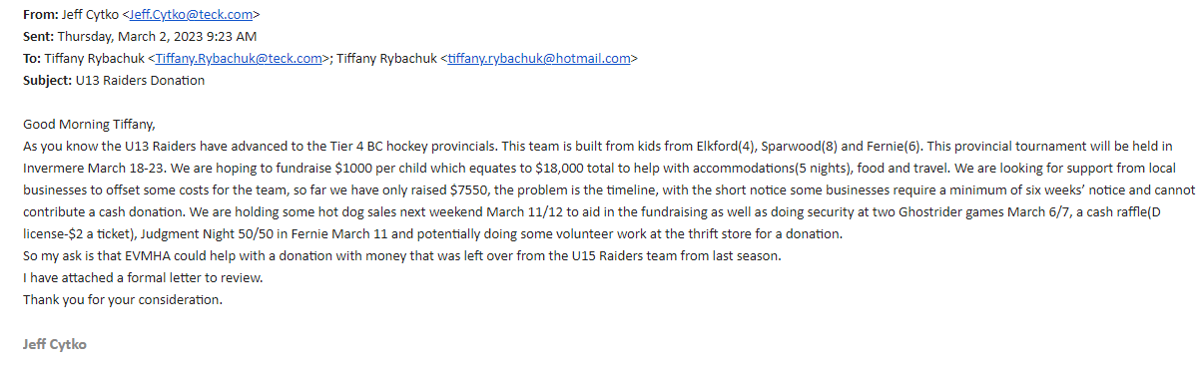

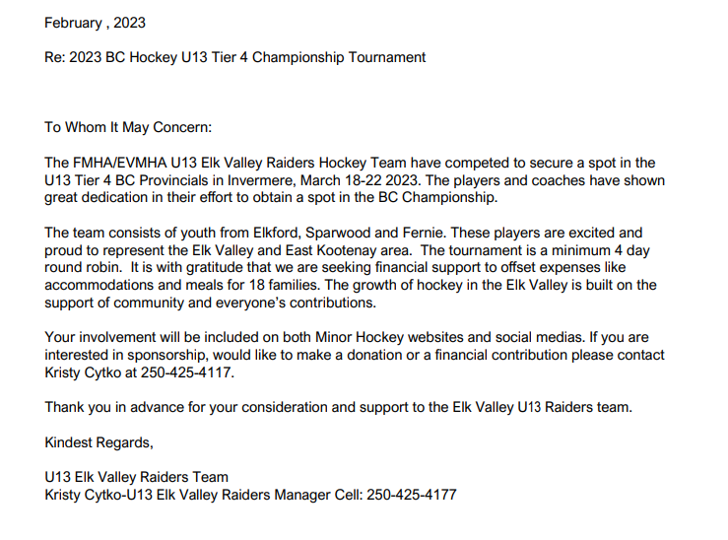

* Lots of discussion, about how much to donate, FMHA will not donate any money to any teams going to provincials. Our banquet is coming up and it was discussed that we will donate $1000 if the parents and each player volunteer to serve and clean up both banquet sessions. Stephanie Motions to have a letter sent to them to offering to volunteer the banquets, Jenna Motions, Justine Seconds All in Favor

1. 50/50 Cheat Sheet see attached

Tanya will put them in the 50/50 boxes along with control sheets to ensure that volunteers do the paperwork properly.

1. Ref Room- The DOE received a complaint/concern from a senior ref that there has been no maintenance on the room and that it is being used as equipment storage and that equipment was just being dropped everywhere. I found this out after I received a complaint from a different ref about the equipment storage and the state of the room.   
     
   There has always been confusion on who takes care of the ref room and it sounds like the last time it was cleaned was when samatha rector and I did it several years ago…  
     
   Spoke to the DOE and they have a plan. The same agreement they have with figure skating in their small room. I have attached a snippet of the email from the DOE. I think we will need to set up for the continual cleaning of the room starting next season. Maybe put out a bid on it? Would be a good part time thing for a student maybe.  1 hour a month to come and take out trash, tidy, wipe down etc. it could also be done by someone wanting to volunteer?

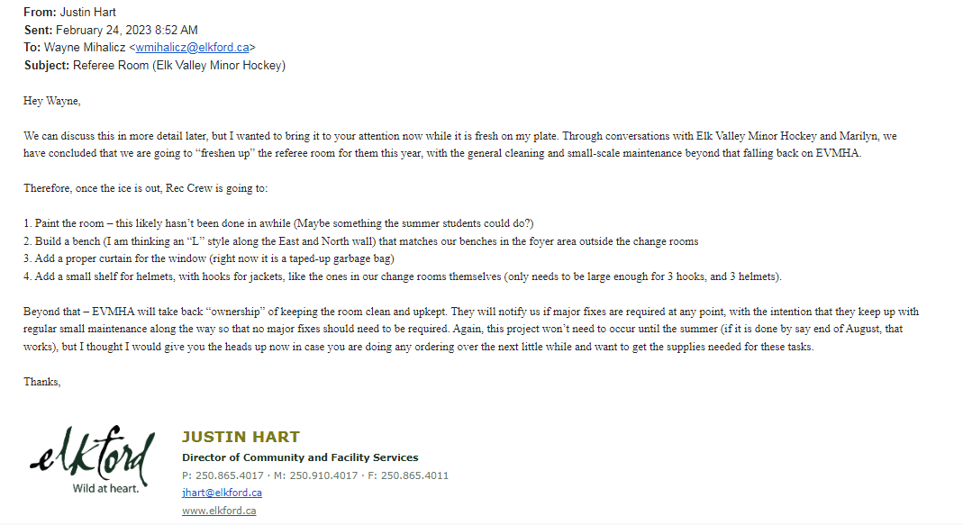

* Discussion about why we pay a $740 a year if they District isn’t going to clean it, and why the handicap bathroom is nicer and cleaner than the ref room? Tanya and Sky will enquire and send an email.

1. Parent/Coach Feedback/ Survey

* Stephanie D will work on a survey and send it out, will make it anonymous and distribute it to all members.

1. Female Goalie

* Jennifer noted that it is more difficult to recruit and encourage females to try the goalie position. It is essential if we want our female program and teams to succeed. There was discussion about offering a try it out night or program during the First Shift program if we win the bid for it. We could offer options to provide gear, or offer registration reimbursement to encourage more females to play. This was just a general conversation and can be brought up before First shift or beginning of next season.

**AGENDA FOR NEXT MEETING**

**ADJOURNMENT**

Meeting adjourned at 7:40 pm by Tiffany Rybachuk as President. The next regular meeting will be @ 6:00pm in Elkford. Next meeting is the AGM on April 6th at 6pm in Elkford at the Community Conference Center.

Minutes Submitted by Jennifer Cherney, Secretary of EVMHA

