

**Elk Valley Minor Hockey Association**

**Meeting Minutes**

**April 23, 2023**

**CALL TO ORDER**

The regular meeting of the Elk Valley Minor Hockey Association was called to order at 5:59 pm on April 23, 2023 in Elkford.

**ATTENDEES: Jenna Kaus, Mike Kaus, Amy Speager, Shawn Speager, Melissa Archambault, Steph Freiheit Sky Johnston, Ashley Charette, Steph Doratty, Hailey Gangne, Kyle Petovello, Jolene Grace, Justine Bowen**

**REGRETS SENT: Jennifer Cherney, Christopher Cherney, Sarah Wilm, Jen Stevens, Tanya Wagner**

**Guests Present**:

Motion to adopt the Meeting Minutes from March 5

1st the motion Melissa Archambault

2nd the motion Mike Kaus

All approved

**BOARD REPORTS**

**PRESIDENT’S REPORT- Stephanie Freiheit**

**Submitted Report: Nothing to report yet.**

**VICE PRESIDENT’S REPORT- Sky Johnston**

**Submitted Report: Nothing to Update**

**TREASURER’S REPORT- Tanya Wagner**

**Report Submitted:**

Current Balance of Accounts as of April 18thare

General: 59505.71

Gaming: 4859.30

Three Bonds: 5475.29 each

2022/2023 Season - Attached is the profit and loss sheet for the season. Please review and ask any questions. Still waiting on some things for official year end.

Also attached is the proposed budget for the 2023/2024 season without any fee increases. Please review and ask any questions. I have taken a lot of the categories and condensed them. We will need to discuss this as new business.

I will pre-pay ice from the gaming account to deplete the account at the beginning of September.

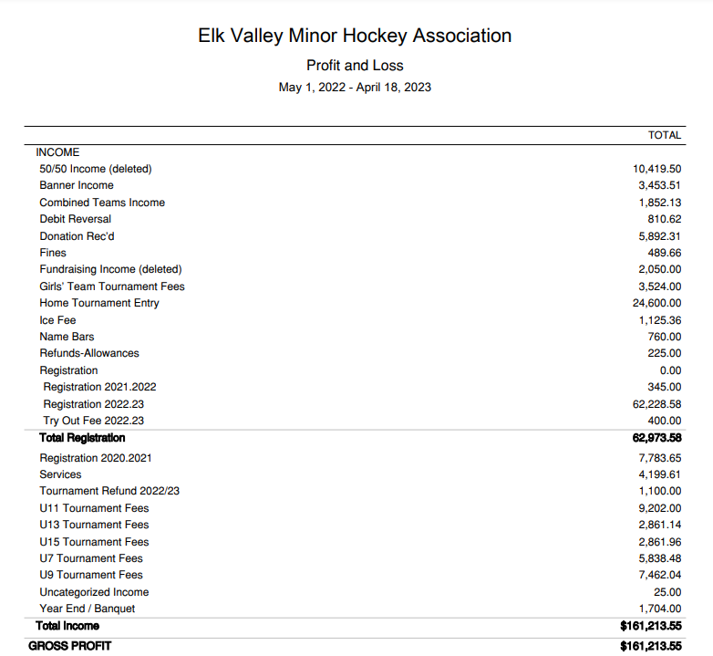

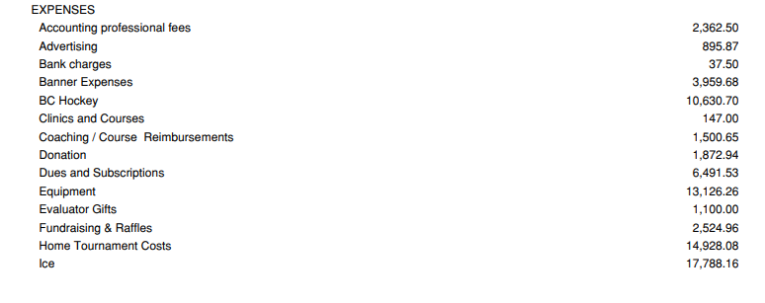

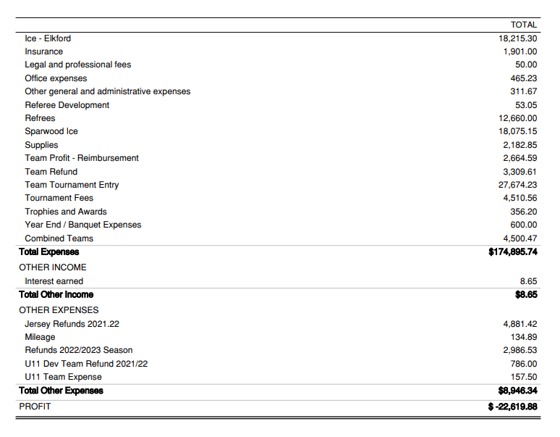

**Proposed Budget**

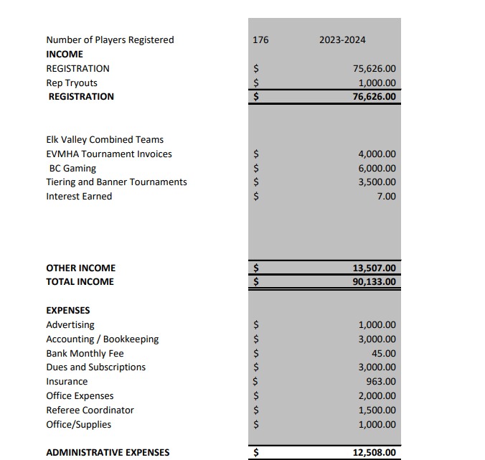

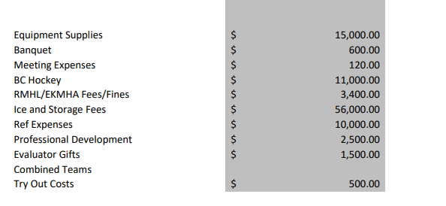

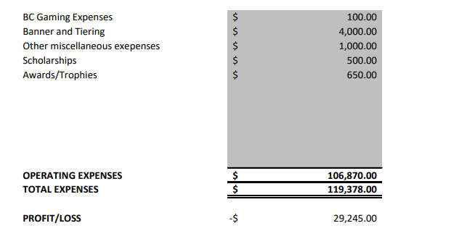

**EK REP- Christopher Cherney**

**Report Submitted**:

East Kootenay April Meeting, April 18, 2023 @ 8 PM

East Kootenay Meetings on Zoom, recorded for notes. 2 in person meetings per year, the AGM in May and the August meeting.

-Operations Update:

Some policy wording updates made, about goalies moving as it reflects how it’s actually done and some other minor issues.

-Minor Committee:

Female coaching programs discussed for this summer, information will be sent to association Presidents and will be on the BC Hockey website.

Discussed resolutions being brought forward to AGM about how the Provincials locations are selected by a table vs the proposed change to policy to allow locations to be changed by the CEO as recommended. Example was Elk Valley hosting U21 as per the current table which makes no sense with no U21 team.

Resolution being brought forward to change terms of directors from 2 to 3 years with the max extending from 8 to 9 years

AGM prep to review resolutions

-Referee:

Clinics coming up for the Summer

-Discipline:

Championships went well no major issues.

-Zones:

U18 Tier1 EK Avalanche won Provincials, U15 played well

-Female Coordinator:

Jen Stevens is continuing on as Coordinator for the upcoming Season

-New Business:

AGM no later than May 30th, notification required 14 days prior – Date Chosen as May 13th, 2 to 4 pm, location TBD

-Zone Lead Discussion:

-Discussion about Justin carrying on as Zone Lead and offering another 1 year term

-Zone Committee Discussion:

- Committee wasn’t very active throughout last season, members felt communication can be improved. The Zone Committee is the chance for the Associations to have input into the Zone program. Sounds like Jeff Pryhitko was EVMHA’s rep on that committee, will need to determine if he is going to continue on. The Zone Committee rep from our Association does not need to be on our board it can be a parent. They are looking for someone to act as a parent liaison, someone with hockey knowledge to assist with evaluations, help with discipline, help with coach selection, it is a working committee.

Frank Cyra-Korsgarrd is the EK Vice President and is on the Zone Committee, please send feedback to him about the Zone Program at [EKMHAVP@gmail.com](mailto:EKMHAVP@gmail.com). He will be sending out a copy of the Zone Policy to the Associations.

-Tiering:

Discussion about how to do tiering for the upcoming season, the proposal is to split by skill then tier. Example would be all A teams (rep, development, travel) would form their league then the remaining House/Recreation teams would tier and be split into a B and C league. Discussion about utilizing a tournament or multiple weekends of games to evaluate the B/C teams, concerns about costs for parents and travel. As the season develops, we could move teams up to B or down to C to match skill levels of teams up until December break. East Kootenay wants input from the Associations, we will need to provide feedback to them. Scheduling Meeting occurs by October 31st.

Reminder for Scheduling Meeting in October, Managers should not book too many tournaments before league scheduling, consensus that 2 tournaments is reasonable pre Scheduling Meeting.

Also a reminder that Banner Tournaments are the 1st and 2nd week of March, please do not book tournaments for those weeks.

-Soap Box Discussion:

Memo of understanding proposed for the U13 Bucks to be changed to the EK Avalanche, this team would still be managed by the Cranbrook association not the Zone program. Operations for the team in the future would be up for discussion. This name change would be good for consistency with the U15 and U18 tier 1 teams and with the teams potentially entering into the SCAHL for the upcoming season.

Everyone is happy to hear there will be tiering for next season.

We need more information about what is required for the EVMHA Zone Rep position.

**CROSS ICE COORDINATOR- Jenna Kaus**

**Report Submitted:**

The final copy of the Policies are attached.

**REFEREE IN CHIEF- Vacant**

**Report Submitted:**

**COACH COORDINATOR- Hailey Gagne**

**Report Submitted: Nothing to Update**

**EQUIPMENT MANAGER- Jolene Grace**

**Report Submitted: Nothing to Update**

**REGISTRAR- Stephanie Doratty**

**Report Submitted: Nothing to Update**

**PUBLIC RELATIONS/WILD WEAR- Sarah Wilm**

**Report Submitted:**

I have access to FB and the website now. I have been updating what I can. If you’d like anything added or posted please let me know.

**ICE COORDINATOR- Melissa Archambault**

**Report Submitted: None Submitted**

**RISK MANAGER- Ashley Charette**

**Report Submitted: None Submitted**

**SPECIAL EVENTS COORDINATOR- Justine Bowen**

**Report Submitted: None Submitted**

**FUNDRAISING COORDINATOR- Amy Speager**

**Report Submitted: Nothing to Update**

**FEMALE COORDINATOR- Sky Johnston**

**Report Submitted:**

**PLAYER DEVELOPMENT- Jenn Stevens**

**Report Submitted: None Submitted**

**Motion to accept Board reports.**

**1st the motion- Steph Doratty**

**2nd the motion- Jolene Grace**

**All approved**

**OLD BUSINESS**

1. See attached final copy of Policies- Thank you Jenna
2. Risk Manager to review and will do an inspection at the end of the season when the ice will be out, and again at the beginning of the season to follow up. (Tabled until after ice is out in Elkford) Ashley is going to reach out to Robyn Hucik or Lee Wilm (previous risk management board members) to see if there is an arena check-list for inspections
3. Year End Banquet Food is ordered. Volunteer times have changed slightly to allow more set up and take-down time. Everyone should check the times. Door prizes are ready to go. Three raffles per session. We are going to use 50/50 tickets, one ticket per player.
4. Update on Feedback Survey

Next meeting. Go over this in detail at the next meeting. The survey is open until April 30.

1. Elkford Ref Room- Tanya and Sky to email DOE to see what yearly fees pay for and about the handicap washroom and why it is always locked. Steph F. is meeting with Elkford in the coming weeks. Add to May old business

**New Business**

1. Discussion of “Closed Meetings” – Jennifer.
   * Apologies for not being here in person. I would like to address the email that was sent out a couple months ago stating we will be following Robert’s Rules and our meetings would be closed moving forward and that association members are not allowed to attend without prior written notice. Robert’s Rules are not mandatory and are a suggestion of how meeting should be run. I disagree with our meetings being closed because we the board should be representing and working for the association and its members. To have our meetings “closed” creates an image that we have something to hide. In my opinion, the only time members/guests shouldn’t be allowed is when something confidential is being discussed. I asked around to a couple associations and they all allow guests/members to attend. I understand that a meeting can be tied up with extra conversation when guests attend so I would suggest that we allow a short question period at the end of our new business and if the guest/member would like to present something to the board that they can email within a certain time period (ie 7 days before) so they can be added to the agenda. I, for one, wouldn’t be on my 6th season of this board if I wasn’t allowed to come to meetings and see what happens and how I could contribute. I am hoping there can be a discussion about this? I would be happy to table it, however I was hoping this would change so that we can post the next meeting and invite any members who wish to attend. If you prefer to table it, I can speak to this at the next meeting. Thank you.
   * Steph Freiheit is open to the idea as long as there are Stipulations- if you have something you want to bring up, you must submit it beforehand. Board meetings are not meant to be an hour-long Q&A. If there are confidential issues, non-board members will need to leave the room.
   * Starting May 2023 Motion to allow non-board members to attend meetings, non-board members can sit in on meetings but cannot participate. If they have an issue they would like discussed at the meeting, they must submit an email to the EVMHA president at least one week before the meeting. The EVMHA Webmaster will post the meetings monthly on Facebook. 1st Justine, 2nd Melissa, All approved.
2. Scholarship Tiffany going to present the scholarships. We currently have two people applying. We will discuss this again at the next meeting after the scholarship deadline is passed.
3. Registration Fees 2023/2024

We must increase our fees to minimize the deficit we are looking at for next season. Motion to increase fees for 2023-2024 season to Initiation $175, U7 $350, U9 $475, U11 $525, U13 $575, U15 $625, U18 $625. 1st Melissa, 2nd Kyle, All approved

1. Approve Budget with new fee structure

Table for next meeting when Tanya is here.

1. Ref Coordinator No volunteers yet, will talk with Fernie at meeting on Thursday.
2. 2023/2024 - Team options in the Elk Valley
   * Female Team
     1. **Sky is meeting next weekend with the Rocky Mountain hockey league.**
     2. **Possible numbers for U13- up to 18 girls**
     3. **Possible numbers for U15-up to 24 girls**
     4. **Numbers are girls from Sparwood, Elkford , Fernie**
     5. **Discussions are ongoing**
   * U11 Dev/Rec
   * U13
   * -U15
   * -U18? (Jennifer) has received an email from CNP asking if our EV U18 players would like to join them to make a CNP team. I had cc’d our ex VP and Lee Wilm (EK Rep) on this first to see if this is even feasible since they are in AB. Lee is currently looking into the rules. His impression is that it may work for EV players but not Fernie. BC hockey allows moving to a neighboring association if your association doesn’t have a team and since our neighboring association is Fernie they could consider CNP as one. Fernie would have to use Cranbrook as their neighboring association. Lee is working on an answer. CNP is getting a Junior B team and would like to grow a U18 team to help for APs and opportunities for the kids to play for the Junior B team. The U18 team would play in the CAHL (Central Alberta Hockey League). I will cc Stephanie the email and continue to work with Lee to see if this is an option. I am sure we have a few other options for the U18s also, ie. Non hitting U15/18 like last year, and if possibly enough players our own EV team combined with Fernie.
   * The Board supports option if we don’t have the numbers to have our own team
3. FMH Discussion

Steph Freiheit is meeting with Fernie on Thursday. Things that came up during our meeting:

* Registration fees
* Allocating the U13 and U15 teams based on which community has the most registrants
* Utilizing both Elk Valley ice and Fernie ice for Raiders games (there were complaints that most U13 Raiders games were in Fernie last year).
* Trying to include bench staff from both communities on teams.
* The Ref Coordinator position.

1. Ready Set Learn Programs on May 4th (Sparwood) on May 8th (Elkford)- Jenna. I can attend the Elkford program but cannot attend the Sparwood program on May 4 from 1-2:30 in Lions Park. Could any other board members attend the session? Kyle said he may be available to help on May 4th at the Sparwood session. Motion to reach out to Teck to see if they will print brochures. If Teck will not print them, spend $150.00 on printing brochures for advertising at Ready Set Learn programs in Sparwood and Elkford. 1st Mike Kaus, 2nd Shawn Speager, All approved
2. Securing our own Web Domain- Sky
3. Adopting Google for non-profits- Sky

Looking into Google non-profit sites. Believes it will look more professional. Sky also thinks we should have our own domain. Our registrar had previously discussed switching to using the Hockey Canada Registry for registration rather than TeamSnap for the 2024-2025 season. The decision needs to be made before February 2024, when we have to renew TeamSnap Subscription. The board would like to know more information about related costs. Sky and Stephanie Doratty are going to continue to look into it.

1. Discussions with EKMHA regarding players playing out of geographical area/next level up- Sky

Sky wondered if there were any policies about player movement between associations that would force Fernie players to play for EVMHA instead of going to Cranbrook. He was specifically concerned about losing female players to Cranbrook. Stephanie Freiheit said she would reach out to Lee Wilm.

1. Equipment

Sky Johnston wondered if we could add questions about equipment sizing on the registration site. Stephanie Doratty said it would be easier to send out something separately after registration.

1. Parent Q&A Session

Concerns about parents being upset over all the travel that occurs with hockey in the EKMHA.

Discussed better ways to communicate with parents. Someone suggested getting Sarah Wilm to put a poll on Facebook to see if parents would be interested in a Q&A session with board members. It was also suggested to add links to registration so parents could learn more about each division. Stephanie Doratty was going to look at adding more information to the registration page.

1. Opening Registration

Motion to run early bird registration on May 1st- June 15th.

1st Melissa Archambault, 2nd Hailey Gagne, All Approved.

Stephanie Doratty will add a preference option for selecting a mixed or all-female team for female registrants.

**AGENDA FOR NEXT MEETING**

1. EVMHA Zone Rep
2. Risk Manager Inspection
3. Feedback Survey
4. Elkford Ref Room
5. Scholarships
6. 2023-2024 Budget
7. Ref Coordinator Position
8. Discussions with FMH
9. Discussion with EKMHA regarding players playing out of geographical area/next level up.
10. Possible parent information session and Facebook Poll

**ADJOURNMENT**

Meeting adjourned at 8:34 pm by Stephanie Freiheit as President. The next regular meeting will be @ 6:00pm in Sparwood at the Chamber of Commerce on May 14 or May 28. Stephanie Freiheit will send out a google doc. We also decided there will be no July meeting.

Minutes Submitted by Jenna Kaus, Half ice/Cross ice Coordinator of EVMHA

X

Sky Johnston

EVMHA Vice President

X

Stephanie Freiheit

EVMHA President